JAVA DATABASE CONNECTIVITY – A STUDY
AIM: To study the essentials of Java Database connectivity and its implementation with respect to MS-Access
Creating & Connecting the Database
Step 1: Creating Blank Database in MS Access

To do this, launch Microsoft Access and create a blank database called purchaseOrder.mdb. The initial screen is shown in Figure 1.
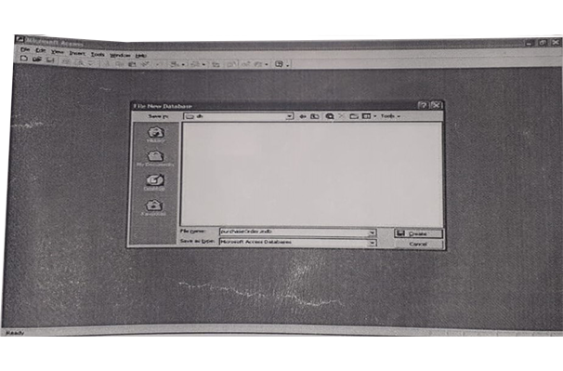
Figure 1
Step 2: Creating a Table in the Database and adding the required fields.

To accomplish this, user can use the Create Table by entering data option as seen in Figure 2.
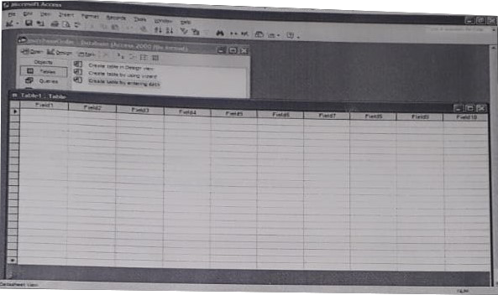
Figure 2
After the user enters all of the data in the table designed, the database should look like Figure 3.
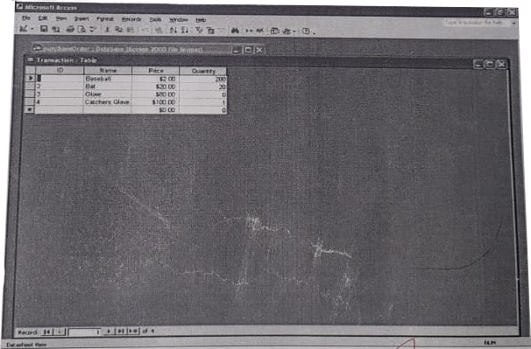
Figure 3
Step 3: Making a connection using ucanaccess

Now that the database is complete, there is one more step to ensure that the Java application which the user develops can make a connection to it i.e. Make a connection to the database. This is an application that allows to connect to the database.
Steps for creating a connection using ucanaccess
- Install ucanaccess 5.0.1
- Extract the files
- Copy ucanaccess-5.0.1.jar and paste it in lib folder

Step 4: Integrating ucanaccess jar files to Netbeans

Select Libraries and choose to Add JAR/Folder to integrate the jar files from ucanaccess. Figure 4 and 5 shows an example for the same.
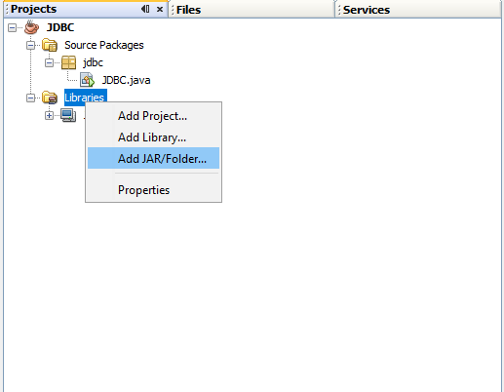
Figure 4
Select all the 5 jar files and open to add them to the netbeans library folder.
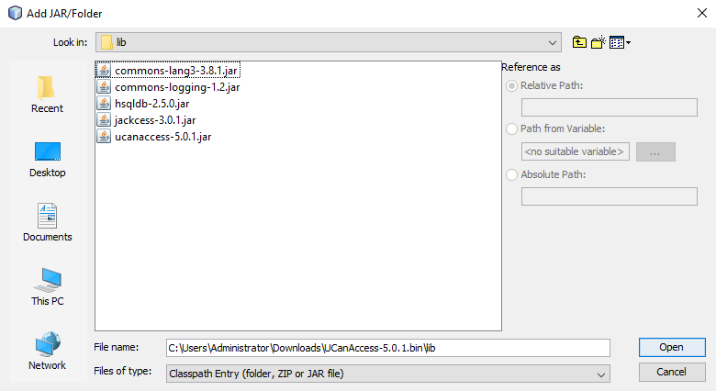
Figure 5
After adding the jar files, redirect to the database file and paste the .accdb file in the package folder of the project.
Figure 6 shows the jar files in the Libraries folder of the JDBC Package.
Once these jar files are added, ucanaccess is able to connect to the program and access the database which we created.

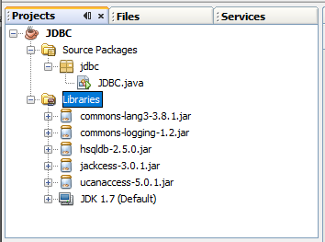
Figure 6

